SCCA PDX
(Performance Driving Experience)
Pocono International Raceway
long course
2007

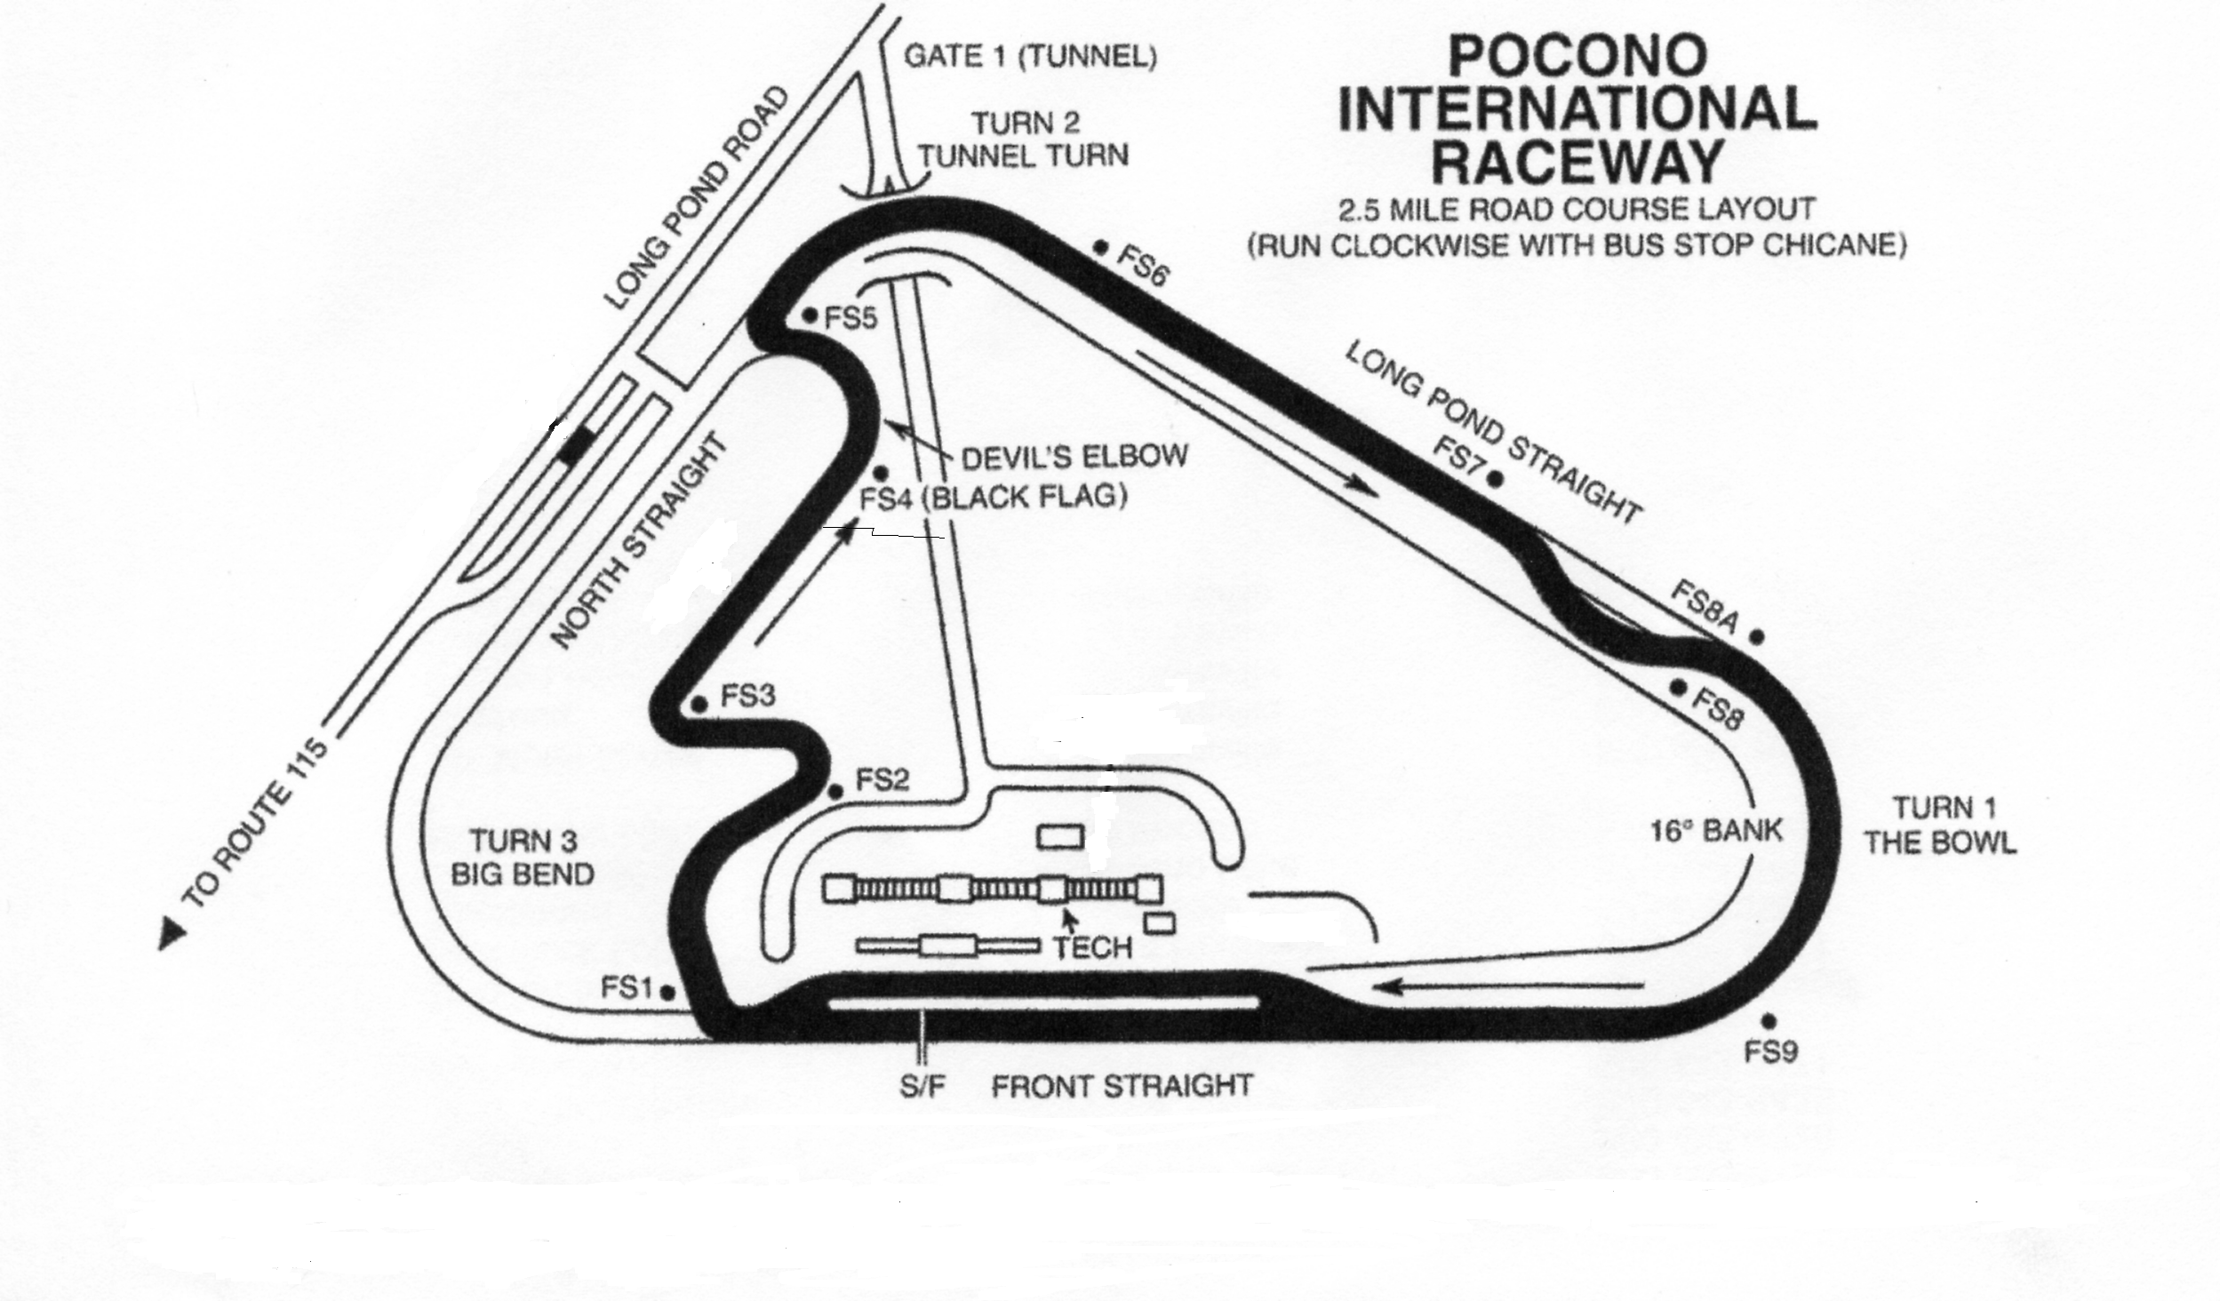
P D X
(Performance Driving Xperience)
June 15 & 16, 2007
Pre-season price: $250 for one day - $450 for two days
(price valid through January 31, 2007)
Bring your own car . . . .
Test your driving ability . . . .
Learn how to handle your car at speed ! ! !
Details will be available soon on the SCCA Tri-Region website:
www.triregionracing.org
To pre-register, contact Judy Bloeser (registrar) at 610-965-0585 or indy33@aol.com

Tri-Region Race Group is the SCCA Road Racing & PDX Time Trials sanctioning group
made up of Northeast PA, Philadelphia, and South Jersey Regions

